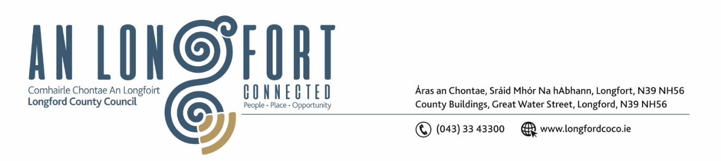

**LONGFORD MUNICIPAL DISTRICT**

***Please note meeting will be held in the Council Chamber, Aras an Chontae and via Microsoft Teams***

**17 October 2023**

**To: Each Member of Longford Municipal District.**

**Dear Member,**

You are requested to attend the Meeting of Longford Municipal District to be held in **the Council Chamber, Aras an Chontae** and **via Microsoft Teams** on **Wednesday 25 October 2023 at 4pm** to transact business, as set out on the agenda hereunder.

**Yours sincerely**,

_______________

**Claire McNabola**

**Meetings Administrator**

**AGENDA**

Prayer before meeting.

**1.** Confirmation of Minutes:

1. Longford Municipal District Meeting held on Wednesday 27 September 2023 – enclosed.

**2.** Matters arising from Minutes.

**3.** Declaration of Interest by Members.

**4.** Management Report

**5.** Consideration of General Municipal Allocation 2024

**6.** Roads Act 1993 Section 11 Declaration of Roads to be Public Roads - Templemichael Business Park, Ballinalee Rd, Longford

**7.** Date for turning on of Christmas Lights 2023

**8.** **Notices of Motions, submitted by Councillors, as listed hereunder –**

**Councillor Uruemu Adejinmi**

I call on Longford County Council to look at repurposing the recreational space in Mac Eoin Park into Social Housing and green space to prevent further dumping of rubbish, and the associated cost of clearing the rubbish, and antisocial behaviour in the area.

**Councillor Gerry Warnock**

I'm calling on Longford MD to mark out by colour pavement and appropriate signage, the designated Bus Stop adjacent to the Boy Scouts Den within The Mall. There are ongoing issues with people parking there and buses cannot at times access their designated area. This is leading to problems with safe disembarkation of passengers (sometimes children with special needs) and at times altercations between bus drivers and people who incorrectly park there.

**6.** **Correspondence**

**(i)** Correspondence received from Longford Garda Station on 2 October 2023 re. Enforcement of parking policy in Longford area - enclosed